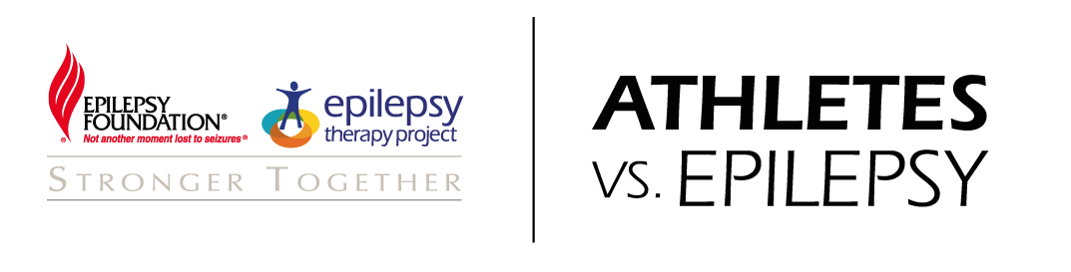
Seattle Marathon & Half Marathon
Sunday, November 30, 2014
10K Walk + Run
Sunday, August 23, 2014

CHARITY PARTNER REGISTRATION FORM
Submit this form by email to nmanning-ashe@efa.org. You will receive a confirmation email that we have received your application as well as a confirmation email that we have accepted your application as part of the Athletes vs. Epilepsy team entry into the SMA.

- Basic Information:
Name
DOB
Gender
Street Address
City
State, Zip
Province
Country
Phone
Email
T-shirt Size
Emergency Contact
Emergency Contact Phone

- Registration Information:
Race | Date | Expected Finish Time | Registration Fee
10K | August 23, 2014 |  | FREE with $500 Athletes vs. Epilepsy Funds Raised
Half Marathon | Sunday, November 30, 2014 |  | FREE with $500 Athletes vs. Epilepsy Funds Raised
Marathon | Sunday, November 30, 2014 |  | FREE with $500 Athletes vs. Epilepsy Funds Raised

- Participant Guarantee (must accompany registration):
Card Type ☐ Visa ☐ MasterCard ☐ Amex ☐ Discover
Cardholder Name:
Card Number:
CCV:
Card Expiration Date:

I understand that as a member of Epilepsy Foundation’s Athletes vs. Epilepsy Seattle Marathon & Half Marathon team, I agree to raise $500, in order to receive a complimentary charity registration provided by Epilepsy Foundation (EF). I understand I will be responsible for any difference in funds not raised by the deadline of 30 calendar days from race day. EF will provide notice of outstanding balance by email. EF will charge any outstanding balance and will provide the applicable tax receipt information.

Participant Signature / Date

Parents Signature (if under 18) / Date

